

Land Information Ontario (LIO) Warehouse

Data Class Name: Conservation Reserve Regulated

Documentation

Produced by: Information Access and Information Management Policy Unit

Ministry of Natural Resources and Forestry

Date: July 27, 2015

**Purpose**

This document provides additional information to support the use of geospatial data. The Physical Model Diagram provides a visual representation of the relationships in the data class. The Data Change History lists all the modelling and access changes that have occurred during the lifecycle of the data class. A data description identifying table and field names is available upon request.

**Need Assistance?**

Please contact LIO Support at [lio@ontario.ca](mailto:lio@ontario.ca) or 705-755-1878 if you require help.

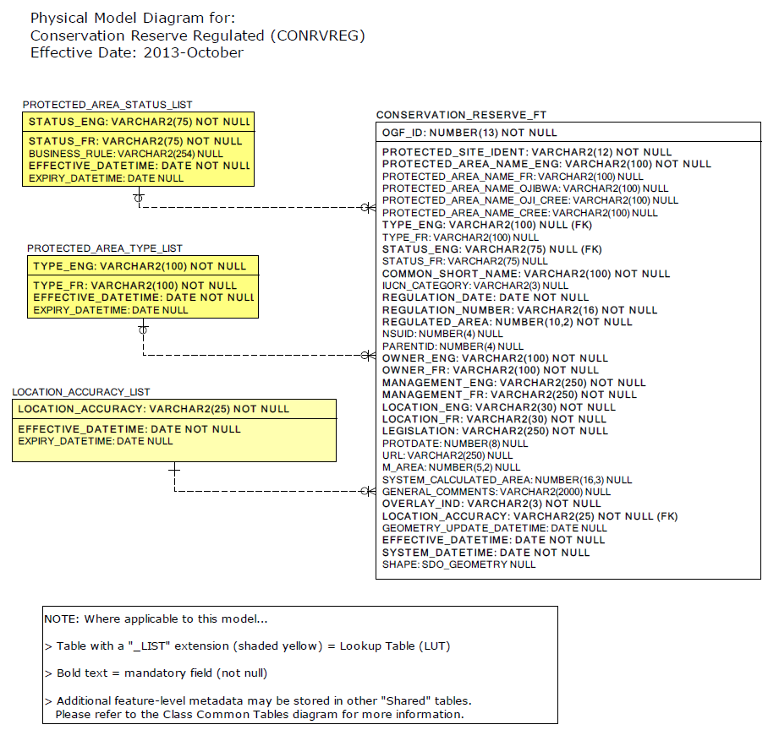

Data Class Change History

Data Class Name: Conservation Reserve Regulated

Data Class Short Name: CONRVREG

| Date  YYYY-MM-DD | Details of Change |
| --- | --- |
| **2013** | Columns Added to support Far North protected areas. |
| **2012** | Column Added: OVERLAY_IND |
| **2008** | Table Added: CONSERVATION_RESERVE-  Type Designation lookup table replaced Protected Area Type LU table. |
| **2008** | Table Changed: CONSERVATION_RESERVE-  Added the following Columns: National Schema ID, Parent ID, Ownership English/French, Management English/French, Location English/French, Legislation, Protection Date, URL and Marine Area. |
| **2008** | Table Added: CONSERVATION_RESERVE-  Status Description lookup table added. |
| **2003** | COLUMNS added to CONSERVATION_RESERVE  - Protected Site Identier  - IUCN Category  - Common Short Name |
| **2000** | NEW Data Class |

**Data Description**  
Please refer to the metadata record for the data description..