User Guide

for

Ontario Trail Network (OTN) Segment and Access Point Geospatial Ontario Data Class

Geospatial Ontario

Digital, Data, Information and Business Services Branch

Corporate Management and Information Division

Ministry of Natural Resources

2024-07-23

Disclaimer

This technical documentation has been prepared by His Majesty the King in right of Ontario as represented by the Ministry of Natural Resources (the “Ministry”). No warranties or representations, express or implied, statutory or otherwise shall apply or are being made by the Ministry with respect to the documentation, its accuracy or its completeness. In no event will the Ministry be liable or responsible for any lost profits, loss of revenue or earnings, claims by third parties or for any economic, indirect, special, incidental, consequential or exemplary damage resulting from any errors, inaccuracies or omissions in this documentation; and in no event will the Ministry’s liability for any such errors, inaccuracies or omissions on any particular claim, proceeding or action, exceed the actual consideration paid by the claimant involved to the Ministry for the materials to which this instructional documentation relates. Save and except for the liability expressly provided for above, the Ministry shall have no obligation, duty or liability whatsoever in contract, tort or otherwise, including any liability or negligence. The limitations, exclusions and disclaimers expressed above shall apply irrespective of the nature of any cause of action, demand or action, including but not limited to breach of contract, negligence, strict liability, tort or any other legal theory, and shall survive any fundamental breach or breaches.

Additional Information

This document does not comply with all the applicable guidelines for accessible digital documents. For an alternative format please email Geospatial Ontario at [geospatial@ontario.ca](mailto:geospatial@ontario.ca?subject=Ontario%20Trail%20Network).

For more information about this document, please contact Geospatial Ontario at [geosptatial@ontario.ca](mailto:geospatial@ontario.ca?subject=Ontario%20Trail%20Network).

Executive Summary

Key Words

Ontario Trail Network, OTN, Trails, Access Point, Trail Segment

Abstract

This user guide details the specifications for the Ontario Trail Network (OTN), including the OTN Segment and OTN Access Point Land Information Ontario (LIO) Data Classes. The OTN contains geospatial networks of trails in urban, rural and wilderness settings managed by a named organization for transportation, recreation, active living or tourism purposes.

Table of Contents

Disclaimer 2

Additional Information 2

Executive Summary 3

Key Words 3

Abstract 3

Table of Contents 4

List of Figures 5

List of Acronyms 6

1. Introduction 7

2. Objectives 7

3. Data Classes 7

OTN SEGMENT (OTNSEGAS) 7

OTN Access Point (OTNACCPT) 7

4. Model Diagram: OTN Segment (OTNSEGAS) and OTN Access Point (OTNACCPT) 9

5. Data Description 10

OTN_SEGMENT_DERIVED_FT 10

OTN_ACCESS_POINT_FT 13

6. Links to Additional Information 14

APPENDIX A: GEO Lookup Tables and Values 15

OTN_ACCESS_POINT_FT: LOCATION_ACCURACY_LIST 15

APPENDIX B: Frequently Asked Questions 16

How to label trails using segment end points or centre. 16

Why are there no names on the Access Points? 18

I want to provide information to the OTN. 18

Is there a place I can see the trail data? 18

List of Figures

Figure 1: An OTN segment (yellow) and associated OTN access point (red point) 8

Figure 2: Model diagram of the Ontario Trail Network (OTN) data classes 9

Figure 3: Select the OTN_SEGMENT_FT layer 16

Figure 4: Select the Labeling tab 16

Figure 5: Enable labeling 16

Figure 6: Open the label properties pane 17

Figure 7: Modify the label position properties 17

Figure 8: Trails are labeled on the map 18

List of Acronyms

ATV: All Terrain Vehicle

GEO: Geospatial Ontario

LUT: Lookup Table

MNR: Ontario Ministry of Natural Resources

OTN: Ontario Trail Network

OTNACCPT: Ontario Trail Network Access Point

OTNSEGAS: Ontario Trail Network Segment

1. Introduction

The Ontario Trail Network (OTN) contains geospatial networks of trails in urban, rural and wilderness settings managed by a named organization for transportation, recreation, active living or tourism purposes. The OTN includes trails for hiking or walking; cycling; x-country skiing and snow shoeing; paddling and portage; equestrian; snowmobiling, all terrain vehicle trails, and off-road motorcycles; ice skating; and trails that are wheelchair accessible.

The OTN project is the combined effort of trail organizations and government to create an accessible trail layer.

For more information on the OTN contact [geospatial@ontario.ca](mailto:geospatial@ontario.ca?subject=Ontario%20Trail%20Network).

2. Objectives

This user guide is intended for users of the OTN Segment (OTNSEGAS) and OTN Access Point (OTNACCPT) data classes. The document describes the extent and context of the information collected for the data classes.

3. Data Classes

OTN SEGMENT (OTNSEGAS)

OTN Segment contains trail segments that define a linear corridor or a looping system through the natural or urban environment. OTN Segments describe the characteristics of a trail such as trail name, length, type, permitted use(s) and organization.

OTN Access Point (OTNACCPT)

OTN Access Point features are represented as points identifying the location where one or multiple trails can be accessed. Not all trails in the OTN have access points. In urban areas where a trail can be accessed along the majority of the linear trail segment, access points will not be included. In remote or less urbanized areas where access to a trail is limited, access points may be included.

There is no physical relationship between OTN Access Point and OTN Segment. However, access points can be associated to trail segments spatially based on proximity.

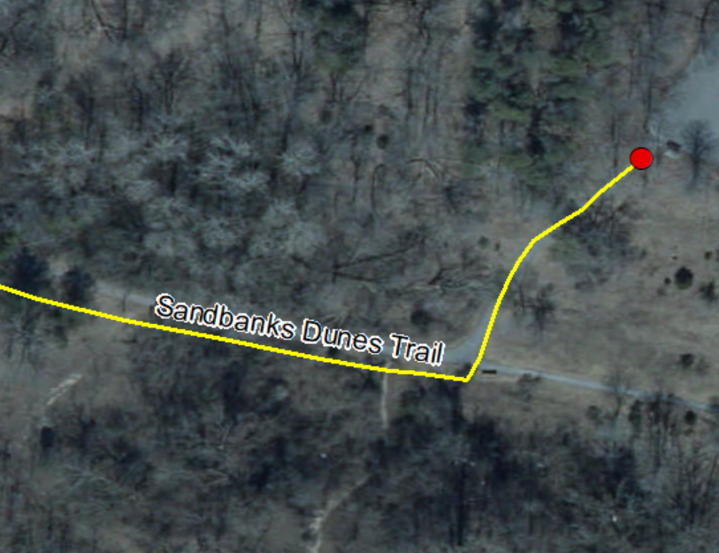

Figure : An OTN segment (yellow) and associated OTN access point (red point)

4. Model Diagram: OTN Segment (OTNSEGAS) and OTN Access Point (OTNACCPT)

Physical Model Diagram for OTN Network (OTNSEGAS) – Denormalized Derived Data Class and OTN Access Point (OTNACCPT)

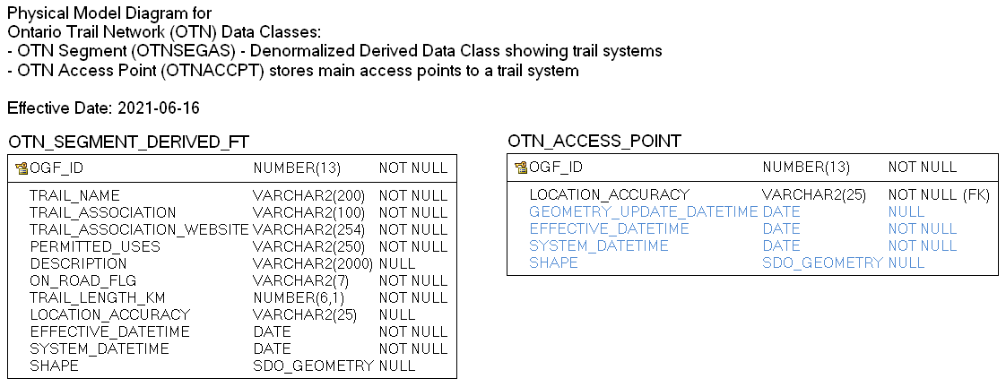

Figure : Model diagram of the Ontario Trail Network (OTN) data classes

**Table Relationships for Class**

|  |  |  |
| --- | --- | --- |
| OTN_ACCESS_ POINT_FT | OTN_ACCESS_POINT_FT. LOCATION_ACCURACY = LOCATION_ACCURACY_LIST. LOCATION_ACCURACY | LOCATION_ACCURACY_LIST |

5. Data Description

The main business area table(s) for this model can be found below.

OTN_SEGMENT_DERIVED_FT

View of Ontario Trail Network (OTN) features including trail segments, permitted trail uses, identified trail associations and website links for authoritative details.

| Column Name | Column Type | Mandatory | Short Name | Description |
| --- | --- | --- | --- | --- |
| OGF_ID | NUMBER(13,0) | Yes | OGF_ID | A unique system identifier assigned to every spatial feature or table record.  SOURCE: OTN_SEGMENT_FT.OGF_ID |
| TRAIL_NAME | VARCHAR2(200) | Yes | TRAIL_NAME | The name that the trail is commonly known as.  SOURCE: OTN_SEGMENT_FT.TRAIL_NAME |
| TRAIL_ASSOCIATION | VARCHAR2(100) | Yes | ASSOC | The managing trail organization that can be contacted regarding additional trail information related to issues, maintenance, operations, administration and problems on the trail.  SOURCE: OTN_ASSOCIATION.TRAIL_ASSOCIATION via OTN_SEGMENT_FT.OTN_ASSOCIATION_ID |
| TRAIL_ASSOCIATION_WEBSITE | VARCHAR2(254) | Yes | WEBSITE | The URL for the trail association website address.  SOURCE: OTN_ASSOCIATION.TRAIL_ASSOCIATION_WEBSITE via OTN_SEGMENT_FT.OTN_ASSOCIATION_ID |
| PERMITTED_USES | VARCHAR2(250) | Yes | PERM_USE | Concatenated field listing all permitted trail uses for this trail. A permitted use for a trail in the OTN can pertain to all or part of the trail. For example, a trail may have “Hiking or Walking, Wheelchair Accessible” as the permitted uses. However, Hiking and Walking may be permitted for the entire length of a trail, whereas Wheelchair Accessible may only be suitable for a portion of the trail. There are also cases where a permitted use only applies for part of a year such as Cross-County Skiing, or snowmobiling. The concatenated value in this field is listed in the order of its assigned trail use rank.  List of Permitted_Uses values:   * All-Terrain Vehicles (ATV) * Cross Country Skiing * Cycling * Dog Sledding * Equestrian * Hiking or Walking * Off-Road Motorcycle * Paddling * Portage * Snowmobiling * Snowshoeing * Wheelchair Accessible * Ice Skating |
| DESCRIPTION | VARCHAR2(2000) | No | DESCR | Free-text description or additional details about a trail.  SOURCE: OTN_SEGMENT_FT.DESCRIPTION |
| ON_ROAD_FLG | VARCHAR2(7) | Yes | ON_RD_FLG | Flag used to identify if one or more portions of the trail follows a roadway. A value of "Yes" indicates that it does, and users should exercise caution due to vehicles. A value of "No" indicates that the trail is completely off-road. A value of "Unknown" means that more information is required to determine if the trail is on/off road.  SOURCE: OTN_SEGMENT_FT.ON_ROAD_FLG |
| TRAIL_LENGTH_KM | NUMBER(6,1) | Yes | TRL_LEN_KM | The length of the trail provided by the trail association or when not available, the calculated trail segment feature length. Measured in Kilometers.  SOURCE: OTN_SEGMENT_FT.TRAIL_LENGTH_KM |
| LOCATION_ACCURACY | VARCHAR2(25) | No | ACCURACY | The accuracy of the location of the feature at an OBM scale. The degree of conformity or closeness of a measurement to the true value.  SOURCE: OTN_SEGMENT_FT.LOCATION_ACCURACY |
| EFFECTIVE_DATETIME | DATE | Yes | EFF_DATE | Date/time the record was created or last modified in the source database.  SOURCE: OTN_SEGMENT_FT.EFFECTIVE_DATETIME |
| SHAPE | SDO_GEOMETRY | No | SHAPE | Geometry attribute. |

OTN_ACCESS_POINT_FT

Point feature representing the main access point to a trail system that is part of the Ontario Trail Network (OTN). This layer should be used together with OTN Segment (OTNSEGAS).

| Column Name | Column Type | Mandatory | Short Name | Description |
| --- | --- | --- | --- | --- |
| OGF_ID | NUMBER(13,0) | Yes | OGF_ID | A unique system identifier assigned to every spatial feature or table record. |
| LOCATION_ACCURACY | VARCHAR2(25) | Yes | ACCURACY | Represents how close the represented mapped feature is in relation to its actual location on the ground.  **Valid Values**  'Not Applicable', 'Over 10,000 metres', 'Within 1 metre', 'Within 10 metres', 'Within 10,000 metres', 'Within 100 metres', ...  (See OTN_ACCESS_POINT_FT: LOCATION_ACCURACY_LIST table) |
| GEOMETRY_UPDATE_DATETIME | DATE | No | GEO_UPD_DT | Date/time the geometry was created or last modified in the source database. |
| EFFECTIVE_DATETIME | DATE | Yes | EFF_DATE | Date/time the record was created or last modified in the source database. |
| SHAPE | SDO_GEOMETRY | No | SHAPE | Geometry attribute. |

6. Links to Additional Information

* Access the official Metadata Record by searching [Ontario GeoHub](https://geohub.lio.gov.on.ca/) for “OTN”, “Ontario Trail Network”, “trails”, “recreation”.
* [Ontario Trails Council (OTC)](http://www.ontariotrails.on.ca/)
* [Ontario Trails Act, 2016, S.O. 2016, c. 8, Sched. 1](https://www.ontario.ca/laws/statute/16o08)

APPENDIX A: GEO Lookup Tables and Values

Listing of Lookup Tables (LUT) and values that are used by the Ontario Trail Network.

OTN_ACCESS_POINT_FT: LOCATION_ACCURACY_LIST

List of valid location accuracies associated to a mapped feature.

| **Column Name** | **Column Type** | **Mandatory** | **Short Name** | **Description** |
| --- | --- | --- | --- | --- |
| **LOCATION_ACCURACY** | VARCHAR2(25) | Yes | ACCURACY | The degree of conformity or closeness of a measurement within the database to its true value in the world. |
| **EFFECTIVE_DATETIME** | DATE | Yes | EFF_DATE | For subscription: Date/time that the record was created in the LIO database. For publication: Date/time that the record was created in the source database. |
| **EXPIRY_DATETIME** | DATE | No | EXP_DATE | Date the record is no longer part of the database, or no longer valid. This is only populated in the history tables otherwise it will be null except for code tables. |

APPENDIX B: Frequently Asked Questions

How to label trails using segment end points or centre.

The steps below presume the use of Esri’s ArcGIS Pro 2.4.

1. Open an ArcGIS Pro document and add the OTN_SEGMENT_FT class to the map.
2. Select the OTN_SEGMENT_FT layer in the contents pane on the left.

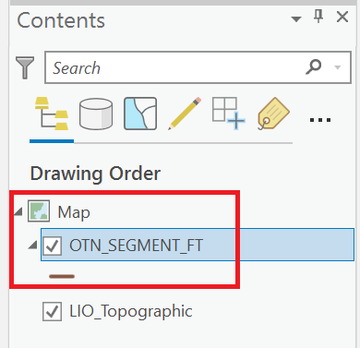

Figure : Select the OTN_SEGMENT_FT layer

1. Select the “Labeling” tab in the “Feature Layer” section of the ribbon menu.



Figure 4: Select the Labeling tab

1. Ensure that the “Enable Labeling” button is active

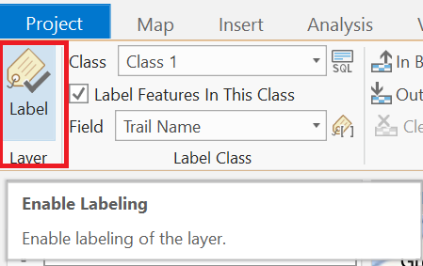

Figure 5: Enable labeling

1. Open the label placement properties pane on the right by clicking the in the “Label Placement” section of the ribbon menu.

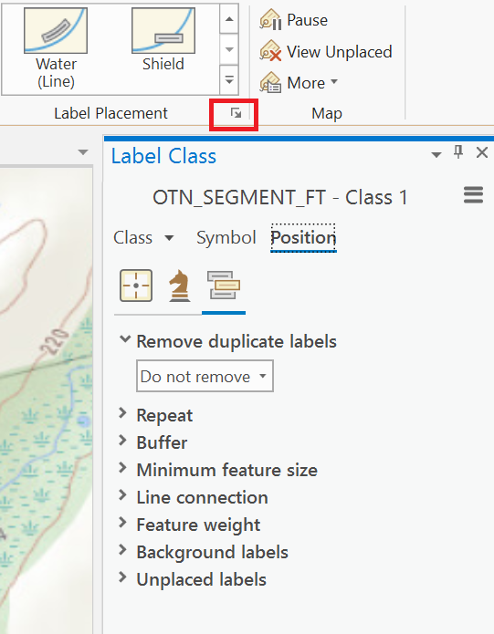

Figure 6: Open the label properties pane

1. Select the label position properties and choose the desired label position from the “Offset along line” dropdown list.

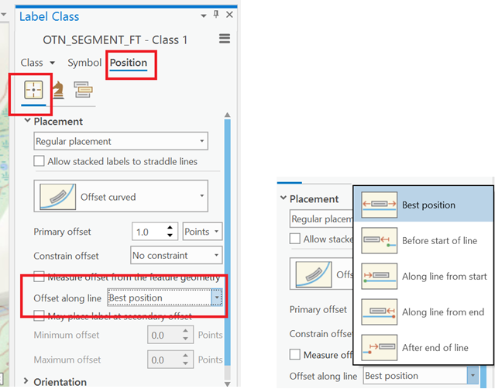

Figure 7: Modify the label position properties

1. Trails should now be labeled on the map.

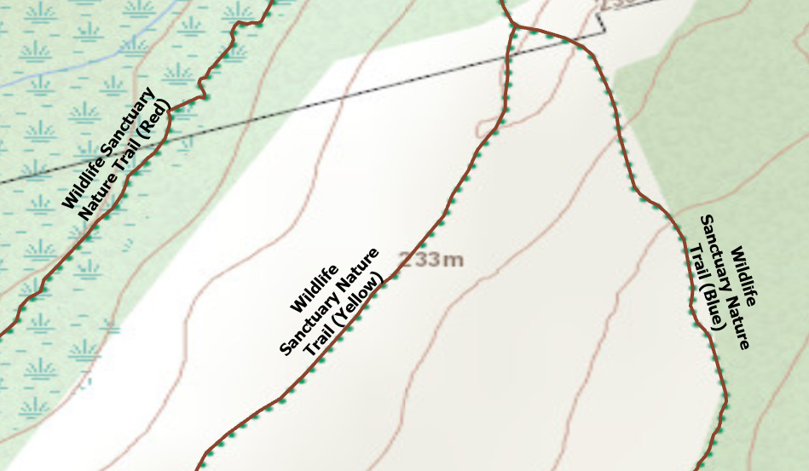

Figure 8: Trails are labeled on the map

Why are there no names on the Access Points?

Access Points identify the location where one or multiple trails can be accessed. Names can be found on the OTN Trail Segment data class. There are no interlayer dependencies between access points and trail segments. Access points relate topologically to one or many trail segments that are within the same general proximity.

I want to provide information to the OTN.

To provide trail information contact Geospatial Ontario. You can email your questions or suggestions to [geospatial@ontario.ca](mailto:geospatial@ontario.ca?subject=Ontario%20Trail%20Network)..

**Is there a place I can see the trail data?**

The MNR has a web map application that you can use to make a topographic map of any area of Ontario that interests you. Trail information is updated annually. For more information visit the [Make a Topographic Map application](https://www.ontario.ca/page/topographic-maps) page.

Version 2425.1