# Dataset Documentation: Ontario Trail Network (OTN) Access Point

## Table of Contents

Table of Contents 1

Purpose 2

Data Class Name: OTN Access Point 2

Data Change History 2

Physical Model Diagram 2

LIO Table Relationships for Class 2

Data Dictionary 3

OTN_ACCESS_POINT_FT 3

Lookup Tables and Values 4

LOCATION_ACCURACY_LIST 4

Cette publication spécialisée n’est disponible qu’en anglais.

This document does not comply with all the applicable guidelines for accessible digital documents. For an alternative format please contact Land Information Ontario at [lio@ontario.ca](mailto:lio@ontario.ca).

## Purpose

This document provides additional information to support the use of geospatial data. The Data Change History lists modifications made during the lifecycle of the data class. The Physical Model Diagram provides a visual representation of the relationships in the data class. It shows the cardinality and relationship between tables and lists the names of the attributes in each table. It also identifies primary and foreign keys. The Data Dictionary and Lookup Tables and Values describe the table and fields.

## ****Data Class Name: OTN Access Point****

Data Class Short Name: **OTNACCPT**

### Data Change History

| **Date** | **Details of Change** |
| --- | --- |
| 2021-07-15 | NEW denormalized derived data class (Open Data) supporting the Ontario Trail Network (OTN). This data class should be used together with the OTN Segment (OTNSEGAS) data class. |

### Physical Model Diagram

Physical Model Diagram for OTN Access Point (OTNACCPT).

2021-06-16

OTN_ACCESS_POINT_FT

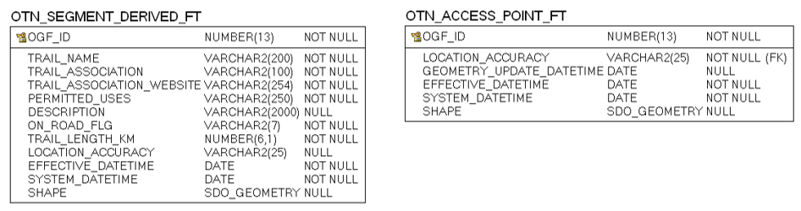

### LIO Table Relationships for Class

|  |  |  |
| --- | --- | --- |
| OTN_ACCESS_ POINT_FT | OTN_ACCESS_POINT_FT. LOCATION_ACCURACY = LOCATION_ACCURACY_LIST. LOCATION_ACCURACY | LOCATION_ACCURACY_LIST |

### Data Dictionary

#### OTN_ACCESS_POINT_FT

Point feature representing the main access point to a trail system that is part of the Ontario Trail Network (OTN). This layer should be used together with OTN Segment (OTNSEGAS).

| Column Name | Column Type | Mandatory | Short Name | Description |
| --- | --- | --- | --- | --- |
| OGF_ID | NUMBER(13,0) | Yes | OGF_ID | Ontario Geospatial Feature Identifier (OGF_ID): A unique system identifier assigned to every spatial feature or table record. |
| LOCATION_ACCURACY | VARCHAR2(25) | Yes | ACCURACY | Represents how close the represented mapped feature is in relation to its actual location on the ground.  **Valid Values**  'Not Applicable', 'Over 10,000 metres', 'Within 1 metre', 'Within 10 metres', 'Within 10,000 metres', 'Within 100 metres', ...  (See LOCATION_ACCURACY_LIST table) |
| GEOMETRY_UPDATE_DATETIME | DATE | No | GEO_UPD_DT | Date/time the geometry was created or last modified in the source database. |
| EFFECTIVE_DATETIME | DATE | Yes | EFF_DATE | Date/time the record was created or last modified in the source database. |
| SHAPE | SDO_GEOMETRY | No | SHAPE | Geometry attribute. |

## Lookup Tables and Values

### LOCATION_ACCURACY_LIST

List of valid location accuracies associated to a mapped feature.

| Column Name | Column Type | Mandatory | Short Name | Description |
| --- | --- | --- | --- | --- |
| LOCATION_ACCURACY | VARCHAR2(25) | Yes | ACCURACY | The degree of conformity or closeness of a measurement within the database to its true value in the world. |
| EFFECTIVE_DATETIME | DATE | Yes | EFF_DATE | For subscription: Date/time that the record was created in the LIO database. For publication: Date/time that the record was created in the source database. |
| EXPIRY_DATETIME | DATE | No | EXP_DATE | Date the record is no longer part of the database, or no longer valid. This is only populated in the history tables otherwise it will be null except for code tables. |

Return to Table of Contents.